STEP 1 - School Setup
Preparing School Information, Inventory, Sampling Plan and Building Floor Plan
Revised March 06, 2024

School administrators should have a general understanding of the school’s maintenance and plumbing history as well as what is currently being used in the facility. The following sections will provide guidance on developing the required information needed for your lead sampling program.

STEP 1: Plumbing History
Use the plumbing history form template to enter general school information and history of the school’s plumbing system (maintenance, upgrades, and/or construction). The template can be found on DEQ’s lead in school webpage (https://deq.mt.gov/water/programs/dw-lead#Admins ). This information can be valuable in determining if lead may be present in the plumbing system. It is understood that some of the information and knowledge may not be available based on age of the school and staff turnover.

As part of completing the plumbing history, understand how water enters and flows through the school’s building(s). As shown in Exhibit 1, in single-story buildings the water comes from the service connection via main plumbing headers. These, in turn, supply water to the smaller plumbing connections which supply water to the faucets, drinking water fountains, and other outlets. In multilevel buildings (Exhibit 2), water is carried to the different floors by one or more riser pipes. In addition, in some buildings, water may be stored in a tank prior to being distributed to the drinking water outlets and fixtures. Remember, for sampling purposes, that water within a plumbing system moves from the water main in the street through the service connection and through the building. Try to learn more about how water flows throughout the school’s facility to better guide your sampling plan.

Exhibit 1: Plumbing Configuration for a Single-Level Building
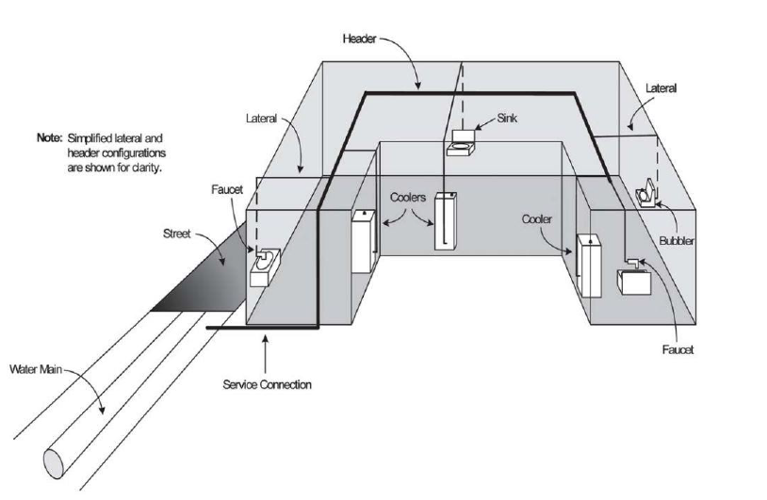

Exhibit 2: Plumbing Configuration for a Multilevel Building

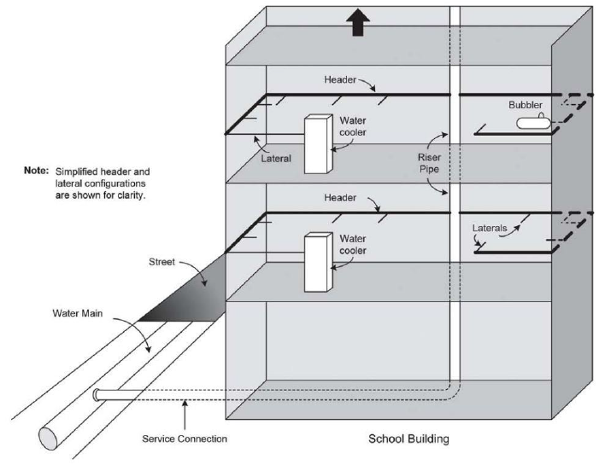

STEP 2: Plumbing Inventory

Conduct a walkthrough of the school.
- Document all water fixtures that are present on the school’s campus. This includes, but is not limited to, shops, mobile classrooms, sports facilities and concession stands. Also include outside water fountains, faucets and hose bibs.

- Assign a fixture number for each fixture. Use the format FX001. Number the fixtures sequentially (ex FX001, FX002, FX003, etc). The fixture IDs will be important when preparing the sampling plan.

- Take note of the visible plumbing for these fixtures. Staff creating the inventory may need to look under sinks or behind cabinets. Document whether faucets have aerators or filters in place to understand all possible sources of lead and any current remediation efforts at each fixture. If your school has bottle filling stations, they will likely have filters.

- Determine if a fixture is used for human consumption (drinking or food preparation). Ask teachers, students, coaches, kitchen staff, custodians or other people that use the building about the fixtures they use for drinking or food preparation. For example, the sports teams may use the outside faucet to fill their water jugs.

- Give a good description of the type, make and model of the fixture. This may be difficult especially with the older fixtures. This is important to determine how many of the same fixtures you have. For example, in the bathrooms the sinks may appear to be all the same make and model and they probably are. If the school is older, there may be a variety of different types of makes and models throughout the facility. Document each type of fixture.

- Give a good location summary of each fixture. The location description should be good enough so that a person with no knowledge of the school could easily find the fixture (ex: 2nd floor boys bathroom, west side, first sink on left). This is also important for repeatability of sampling. Staffing may change over the years but the same fixture may have to be sampled every three years. Taking photographs of the locations can be very helpful.

STEP 3: Determine Sampling Locations

The next step is to identify locations where the water will be sampled for lead testing. This is called the sampling plan. The following locations are required to be part of the sampling plan:

- All drinking water fountains including bottled water dispensers.

- All kitchen faucets or other fixtures that are used for food preparation.

- All other fixtures that are used for human consumption.
  - Schools may opt to select a representative number of the other human consumption fixtures (HCFs).
  - The selected sample locations must be representative of all the types of HCFs remaining. Review the school’s fixture inventory. Look for fixtures that are the same make/model and installation date. These may include bathroom, nurse’s office, concession stand, teacher’s lounge or classroom faucets. Select a representative number of each type of fixture for the sampling plan.
  - The selected sample locations should also be representative of the school building(s). Use your school schematic or layout (Section 4) to make sure all areas of your school are covered by your proposed sample locations.

- On the inventory form, mark “yes” in the sampling plan column for all the fixtures that will be part of the sampling plan.

STEP 4: Preparing the School Building Floor Plan
A simple building floor plan showing the fixture locations will have to be completed. The floor plan is important to show that the selected sample locations cover the entire school. The layout can be a simple sketch or aerial photo of the school building(s) showing where the fixtures are located. It can be completed by hand and does not require professional draft services. Schools can also use their evacuation maps. See the two examples below. The following items should be on the layout, please note that fixture locations can be approximate:
- Write the fixture IDs on the fixture locations. The fixture IDs should match the IDs on your Plumbing Inventory.
- Mark where your water service enters the building(s).
- Mark the well location, if your school has its own well.
- Mark the direction of north with an arrow on the layout. Knowing the orientation of the school will help in discussions with stakeholders.
- Prepare a drawing for each floor and building.
- Keep the floor plan simple and easy to read.

Example 1
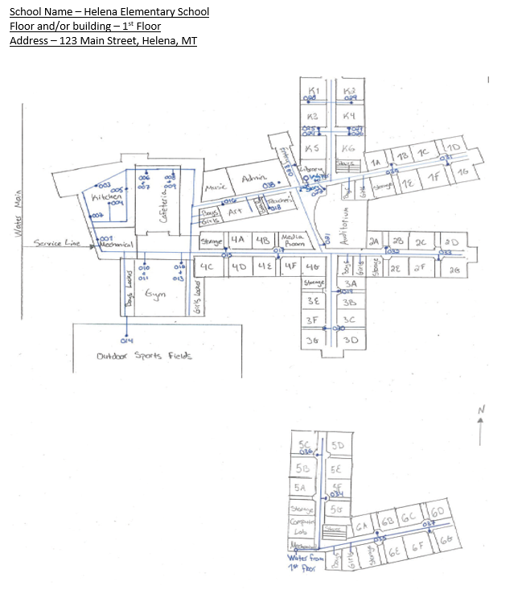

Example 2
